***Project Name – “ COURSERA ”***



**# OVERVIEW** :

**It is an Educational Website. Coursera is the global online learning platform that offers anyone, anywhere access to online courses and degrees from world-class universities and companies. It provide certificate to the courses which you buy and learn. You can easily learn any subject of you interest. Coursera will provide you full support in achieving your desired dream.**

**# HOMEPAGE** :

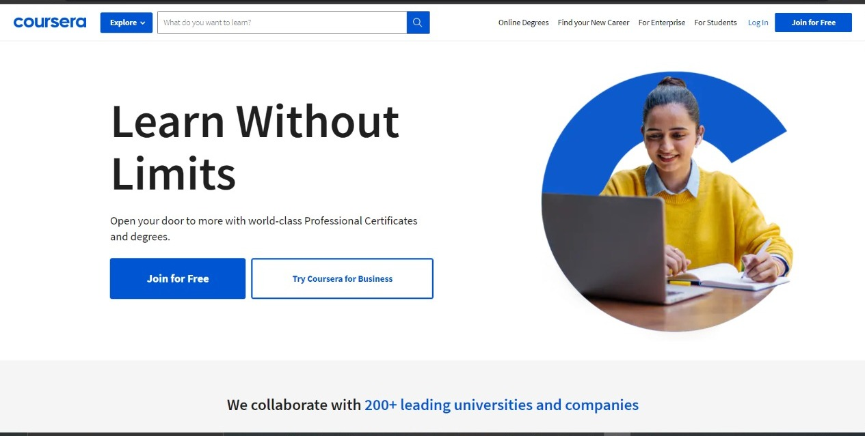

**My home page consists of :**

1. **Logo**
2. **Search bar**
3. **Images**
4. **Explore(Conation info of courses)**
5. **Joining option**
6. **Login**
7. **Footer- About the company, Contact details , Helpline Number , Brief description.**

**# SINGUP** :

1. **Full name.**
2. **Email**
3. **Password**
4. **Join for free( Submit button)**
5. **Footer – Already on coursera .Login.**

**# Main page**  :

**Main page consists of the following –**

**1 . Navigation bare :**

* **Logo**
* **Search bar**
* **Explore option( Consist info of courses)**
* **User account option**
* **Notification option**
* **Online courses option**
* **Find your new carrer option**
* **For enterprise option**
* **For universities option**

**2 . A welcome statement .**

**It is the welcome statement at center of page.**

**3 . There will be 3 options :**

1. **HOME- It consists of all the courses. From here user can select its desired course**
2. **IN PROGRESS- It consists of all the courses which are in progress.**
3. **COMPLETED- It consists of all the courses which user has completed.**

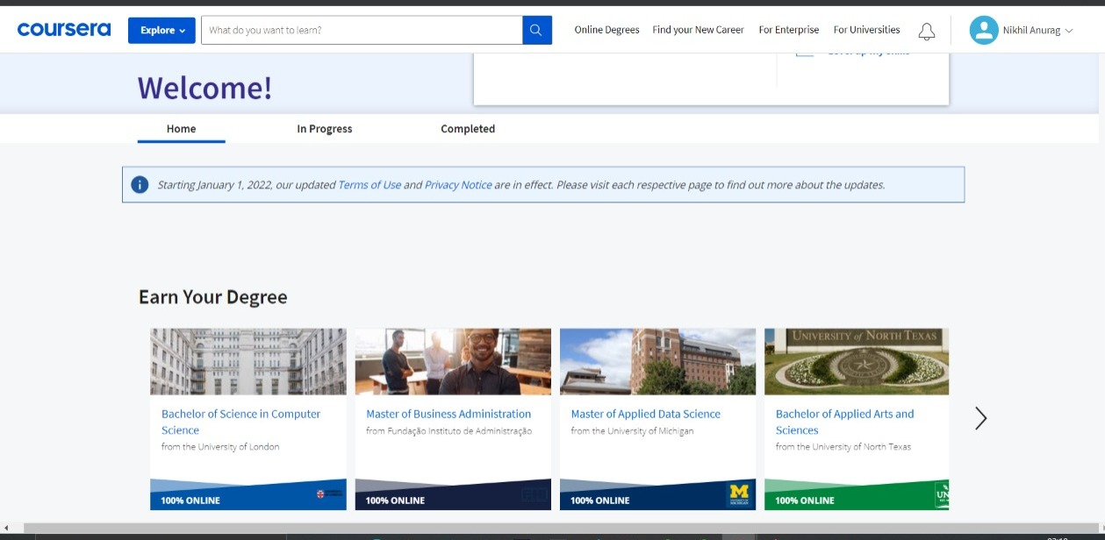

**# Payment page :**

* **Payment Method :**

1. **Patytm**
2. **Google-pay**
3. **Phone-Pay**
4. **BHIM-UPI**
5. **Credit-Crad**
6. **Debit-Card**
7. **Net-Banking**

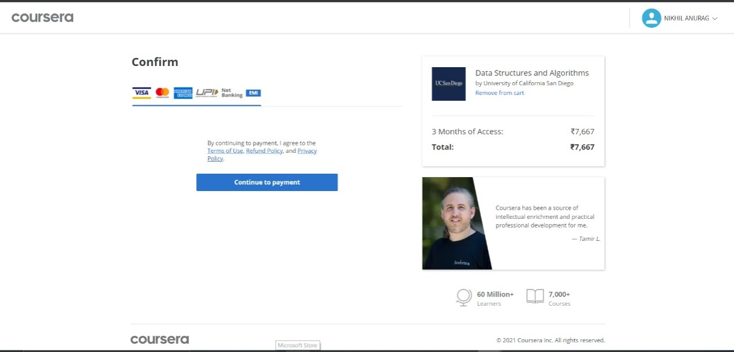

***--THANK YOU--***